Earth’s History Test Review
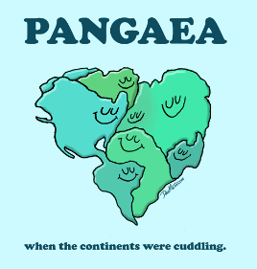
1. Describe each of the 3 different rock types.
2. Draw a diagram of the layers of the Earth and label the inner core, outer core, mantle and crust. Give a brief description of each layer.
3. What is the difference between the lithosphere and the asthenosphere?
4. List and describe the 3 pieces of evidence that supports continental drift.
5. What is Pangaea?
6. What are tectonic plates?
7. Describe Sea floor spreading. How does the age of the change around the mid ocean ridge?
8. Describe how convection current causes the tectonic plates to move. Make sure you include information regarding temperature and density.
9. Describe each of the 3 plate boundaries. What gets made at each boundary?
10. What is the difference between absolute and relative age? Give an example of each. 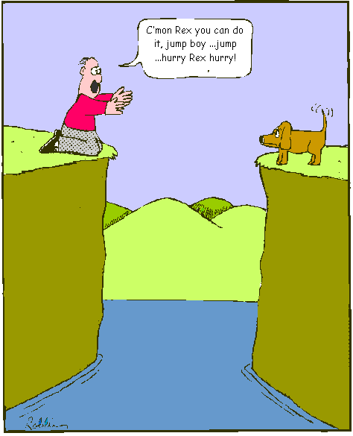
11. What is the Law of superposition? Does it tell you absolute or relative age? What is the rule about igneous rock cutting through the layers?
12. How do you find the absolute age? In what kind of rocks can you find absolute age? Why can’t you find the absolute age of sedimentary rocks?
13. When was the most recent mass extinction?
14. What are fossils?
15. What are index fossils? Why are they useful? What is an example of an index fossil?
16. What information can scientists get from ice cores?
17. The Phanerozoic (current) Eon is divided into what 3 eras?
18. Describe what type of animals were/are found in each of the 3 eras.
19. In what era do you find humans?
20. What must happen to move on to the next era?
21. What are the first 3 eons in the Earth’s History called?
22. What is the first living thing found on Earth? Why was the formation of bacteria so important?
23. Why aren’t fossils found in igneous rocks?
24. What is an unconformity?
25. List the four theories scientists think were the cause for the dinosaurs’ extinction.

